Dependency Injection(DI)
Dependencies are external code, services, or components that a software project needs in order to function properly.
Definition:
- It is a design pattern
- The objects receive their dependencies from external sources rather than creating internally.
- Through DI inversion od Control(IoC) is achieved , that is instead of a class creating and controlling what dependencies it uses, something external provides it
Three types of DI
- Constructor Injection – most commonly used, here the dependency is injected via the constructor
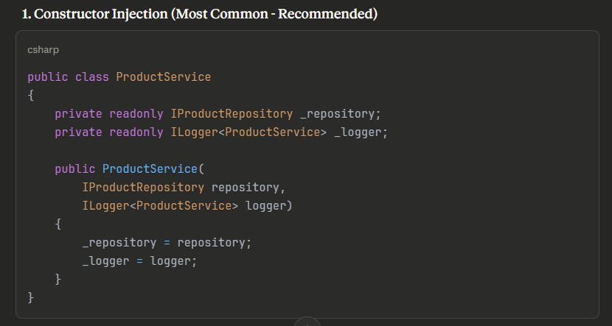

- Property Injection : - this is used for optional dependencies, rarely used in .Net core
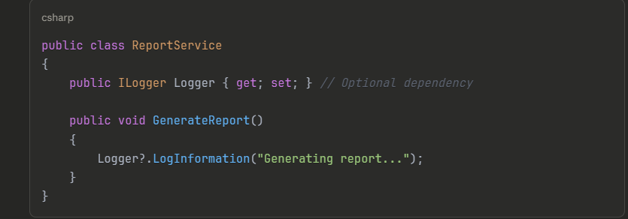

- Method Injection : this is used when the dependency changes per method call
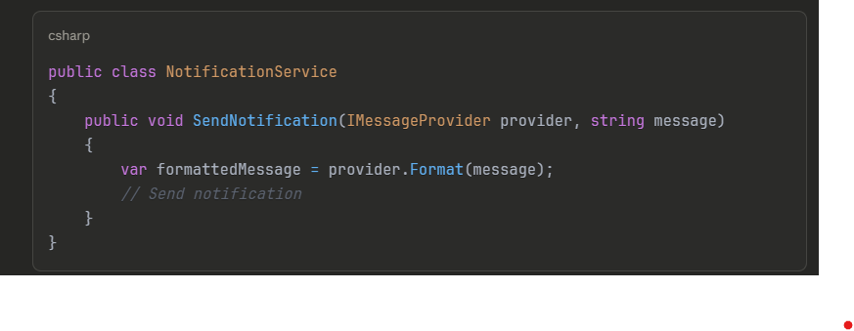

.Net Built-in DI Container
.NET has a built-in DI container (in Microsoft.Extensions.DependencyInjection). You configure it in Program.cs:
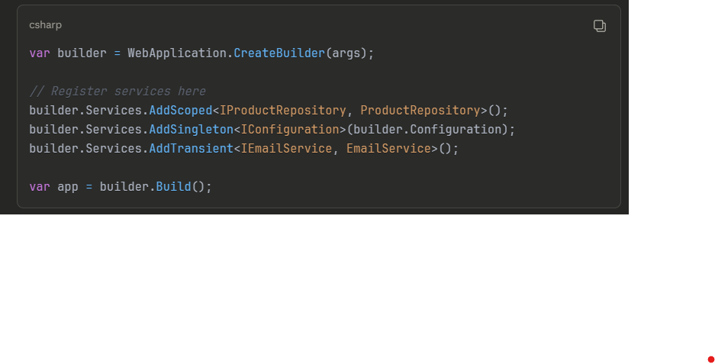

Service Lifetime – Critical Concept
The lifetime determines when instances are created and disposed
An instance is a specific object that is created from the class in memory
Lifetime determines how long an instance lives and when it gets reused or destroyed

- Transient (Add Transient) – it is like disposable cups, use once and throw away
builder.Services.AddTransient<IEmailService, EmailService>();
- New instances is created every time it is requested
- Instances is not shared
- Disposed when scope ends

When to use:
- Lightweight, stateless services
- Services that shouldn't be shared
- Example: EmailService, PdfGenerator, DataValidator
Memory consideration: With 10,000 concurrent users, if each request needs 5 transient services, you create 50,000 instances per request cycle!

- Scoped (AddScoped) – commonly used for web application
builder.Services.AddScoped<IProductRepository, ProductRepository>();

scoped is like a rental car for a day trip – use throughout the trip, return at the end

what scoped does?
  - One instance per request/scope
  - Same instance shared with the HTTP request
  - Disposed when the request ends
  - New instance for next request

When to use:
- Database contexts (Entity Framework DbContext)
- Unit of Work pattern
- Request-specific services
- Example: DbContext, repositories, services that need consistency within a request

- Singleton (AddSingleton)
builder.Services.AddSingleton<ICacheService, MemoryCacheService>();
  - One instance for the entire application lifetime
  - Same instance shared across all requests and users
  - Never disposed (until app shutdown)

When to use:
- Stateless services
- Configuration objects
- Caching services
- Logging (though ILogger is handled differently)
- Example: Configuration, Cache, Connection pools

Why This Matters for Microservices
- Service Discovery: Each microservice registers its own dependencies
- Loose Coupling: Services communicate via interfaces
- Testability: Each microservice can be tested independently
- Scalability: Proper lifetime management prevents memory issues
- Configuration: Each service can have different implementations

